PHIẾU BÀI TẬP MÔN TIẾNG ANH LỚP 5 (phiếu 13)
- complete the sentences
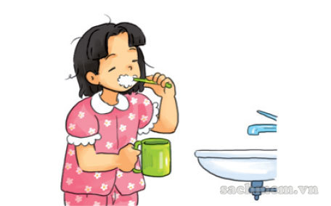 She usually …………….. my teeth every day.
He often …………. morning …………….. in the morning.
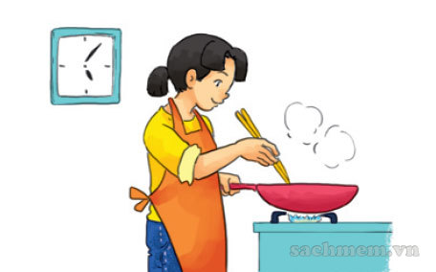 She often ………………………dinner.
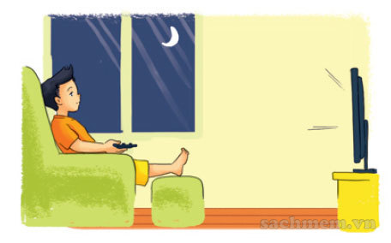 He sometimes………………. TV.
- Let’s talk
Ask and answer questions about your daily routines.

What do you do in the morning/afternoon/evening?
I always/usually/often/sometimes…………….. .

- Read and complete
Like do TV play usually
Hi. My name is Quan. Every morning, I get up early. I (1) ………. morning exercise, have breakfast and then go to school. After school, I (2)………. do homework with my classmates. Then I often go to the sports centre and (3)…….. football. In the evening, I sometimes watch (4) ………. I (5)………. watching films after dinner.
IV. Write about you.
1.What do you do in the morning?
.................................................................................................................................
2. What do you do in the afternoon?
……………………………………..………………………………………………….
3. Do you go to bed early in the evening?
………………………………………….. ..……………………………………………
4. How often do you watch TV?
………………………………….……………………………………………………..
- Look and write.
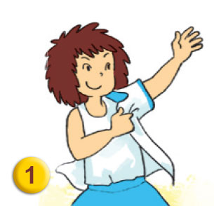…………………………………………………………………………………………………………………
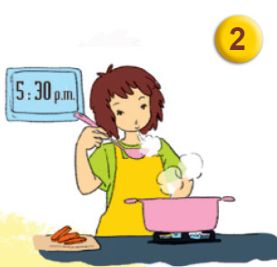……………………………………………………....
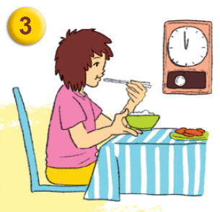…………………………………………………...
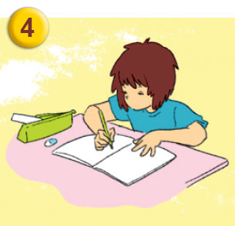……………………………………………………
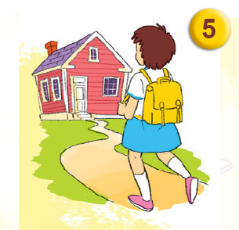…………………………………………………………………………....

ĐÁP ÁN
I
- She usually brushes her teeth every day.
- He often does morning execrise . in the morning.
- She often cooks dinner.
- He sometimes watches TV.
- Let’s talk
Answer vary
- Read and complete
Like do TV play usually
Hi. My name is Quan. Every morning, I get up early. I (1) do morning exercise, have breakfast and then go to school. After school, I (2) usually do homework with my classmates. Then I often go to the sports centre and (3) play football. In the evening, I sometimes watch (4) TV. I (5) like watching films after dinner.
IV. Write about you.
Answer vary
V.look and write
1. gets dress
2. cook dinner
3. have lunch
4.do homework
5.go home

