PHIẾU BÀI TẬP MÔN TIẾNG ANH LỚP 5 (phiếu 18)
- Look and make sentences.
Model sentence: What did the tigers do when you were there?
They roared loudly.
A. 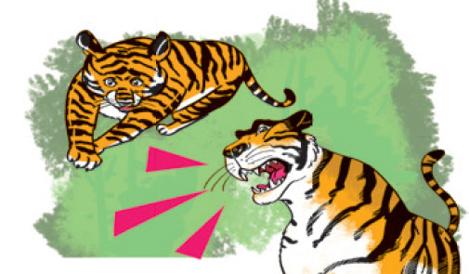 B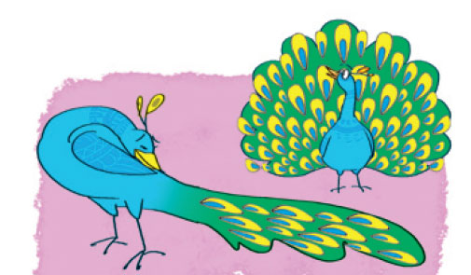
C. 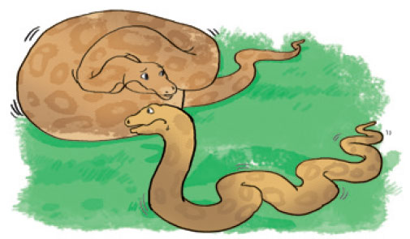 D. 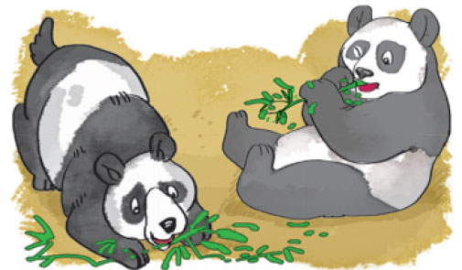
- ………………………………………………………………………..
- ……………………………………………………………………….
- ………………………………………………………………………..
- ……………………………………………………………………......
- Read and circle a or b
1. What did the gorillas do when Nam was at the zoo?
a.They moved quickly.
b.They moved slowly.
2.What did the pandas do when Quan was at the zoo?
a.They moved slowly and they ate quickly.
b.They moved quietly and they ate slowly.
3.What did the peacocks do when Phong was at the park?
a.They eat slowly.
b.They moved beautifully.
III. Write about your friend last visit to the zoo.
I went to the zoo with last ……………………………………………………………….
At the zoo, I saw ………………………………………………………………………...
The and the …………………………………………………………………………….
I think the animals at the zoo are ……………………………………………………….
…………………………………………………………………………………………..
IV. Em hãy chia các động từ trong ngoặc theo thì.
1. Every morning, Linda (get)………......up at 6. She (have) …………… Breakfast at 6:10. After breakfast, she (brush) …………..her teeth. She (go) ……………..to school at 6:30. She (have) ……………lunch at 11:30 at school.
2. We (watch) …………….T.V every morning.
3. I (do) ……………………my homework every afternoon.
4. Mai and Lan (play) ………………….games after school.
5. Vy (listen) ………………to music every night.
6. Where (be) ………………..your father now? He (read) ………………..a newspaper.
7. What ………….you (do) ………………? I (be) ……….a student.
8. Where ………….you (go) ……………….now?
I (go) ………………to the market.
9. She is cooking and we (do) ……………………..the housework.
10. He isn't in the room. He (play) ………………..in the garden.
Đáp án
- Look and make sentences.
a/ What did the tigers do when you were there? They roared loudly.
b/ What did the peacocks do when you were there? They moved beautifully.
c/ What did the pythons do when you were there? They moved slowly.
d/ What did the pandas do when you were there? They ate quickly.
- Read and circle a or b
1. What did the gorillas do when Nam was at the zoo?
a.They moved quickly.
b.They moved slowly.
2.What did the pandas do when Quan was at the zoo?
a.They moved slowly and they ate quickly.
b.They moved quietly and they ate slowly.
3.What did the peacocks do when Phong was at the park?
a.They eat slowly.
b.They moved beautifully.
III. Write about your friend last visit to the zoo.
Answer vary
IV.
1. Every morning, Linda gets up at 6. She has breakfast at 6:10. After breakfast, she brushes her teeth. She goes.to school at 6:30. She has lunch at 11:30 at school.
2. We watch T.V every morning.
3. I do my homework every afternoon.
4. Mai and Lan play games after school.
5. Vy listens to music every night.
6. Where is your father now?
He reads a newspaper.
7. What do you do ? I am a student.
8. Where are you going now?
I am going to the market.
9. She is cooking and we are doing the housework.
10. He isn't in the room. He plays.in the garden.

