PHIẾU BÀI TẬP MÔN TIẾNG ANH LỚP 5 (phiếu 15)
- Look and make sentences.
Model sentence: How many lessons do you have on Mondays?
I have five:Maths, IT, Science, Vietnamese and English.
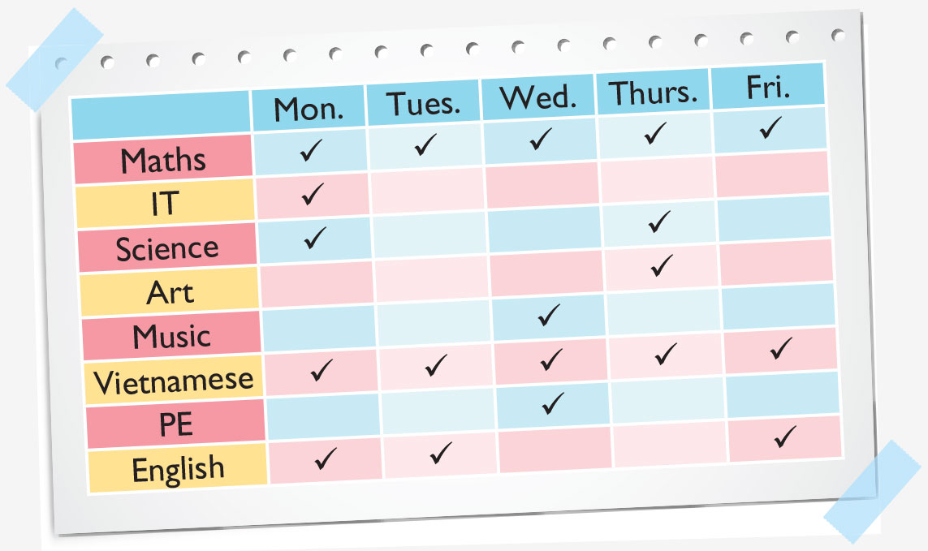
- ………………………………………………………………………..
- ……………………………………………………………………….
- ………………………………………………………………………..
- ……………………………………………………………………......
- Reed and complete and red aloud four times
My name’s Quynh. I’m in Class 5A2, Co To Town Primary School. My school year started in August. I go to school every day except Saturday and Sunday. I have four lessons a day. Today is Wednesday. I have Maths, Vietnamese, Music and English. I have Maths and Vietnamese every schoolday. I have Music once a week and English four times a week.
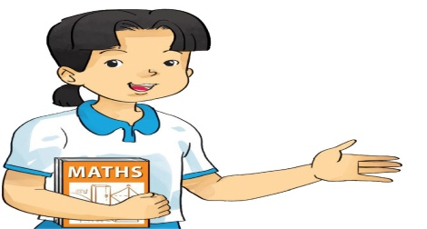
1.Mai’s school started in…………………. .
2.She goes to school every day except……………. .
3.She has…………………. lessons a day.
4.She has……………… on Wednesday.
5.She has Music………………….. .
6.She has English ………………………….

- Make sentence.
Model sentence: How often do you have Art? I have it once a week.

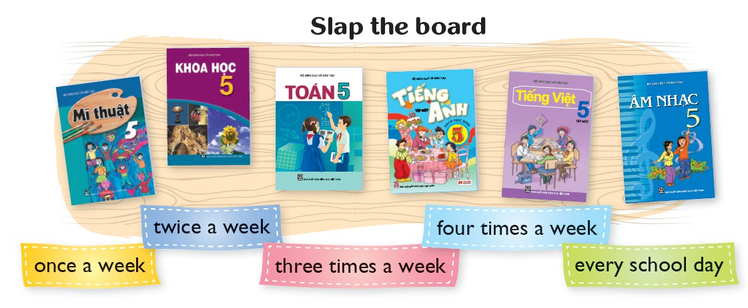
- …………………………………………………………………………………………
- …………………………………………………………………………………………
- …………………………………………………………………………………………
- …………………………………………………………………………………………
- …………………………………………………………………………………………
Đáp án
- Look and make sentences.
- How many lessons do you have on Tuedays?
I have three :Maths, Vietnamese and English.
- How many lessons do you have on Wednesdays?
I have four :Maths, Music, Vietnamese and PE.
- How many lessons do you have on Thursdays?
I have four :Maths, science,Art and Vietnamese .
- How many lessons do you have on Tuedays?
I have three :Maths, Vietnamese and English.
- Reed and complete
My name’s Quynh. I’m in Class 5A2, Co To Town Primary School. My school year started in August. I go to school every day except Saturday and Sunday. I have four lessons a day. Today is Wednesday. I have Maths, Vietnamese, Music and English. I have Maths and Vietnamese every schoolday. I have Music once a week and English four times a week.
1.Mai’s school started in August.
2.She goes to school every day except Saturday and Sunday.
3.She has four lessons a day.
4.She has Maths, Vietnamese, Music and English on Wednesday.
5.She has Music once a week .
6.She has English four times a week.
- Make sentence.
- How often do you have Science? I have it three times a week.
- How often do you have Maths? I have it every school day.
- How often do you have English? I have it four time a week.
- How often do you have Vietnamese? I hav e itevery school day.
- How often do you have Music ? I have it twice a week.

