PHIẾU BÀI TẬP MÔN TIẾNG ANH LỚP 5 (phiếu 10)
Unit 9: When will Sports Day be?
I. Vocabulary: (Từ vựng)
1. Sports Day: ngày hội thể thao
2. singing contest : cuộc thi hát
3. Independence Day: Ngày Độc lập
4. Table tennis : bóng bàn
Em hãy học thuộc lại các từ mới.
II. Sentence patterns: (Mẫu câu)
1. Khi muốn hỏi các sự kiện trong trường sẽ diễn ra khi nào ta hỏi như thế nào.
When will ……… be? It’ll be on Saturday.
Ví dụ: When will Sports Day be?
Cách trả lời: It’ll be on Saturday.
Từ ví dụ trên em hãy lấy them 5 ví dụ.
2. Khi muốn hỏi bạn sẽ làm gì trong các sự kiện đó ta dùng câu hỏi.
What are you going to do on………….? I’m going to play football
Ví dụ: What are you going to do on Sports Day?
Câu trả lời: I’m going to play football
Từ ví dụ trên em hãy lấy thêm 5 ví dụ.
III. Homework: (Bài tập)
Exercise1: Look at the picture and write the correct word.
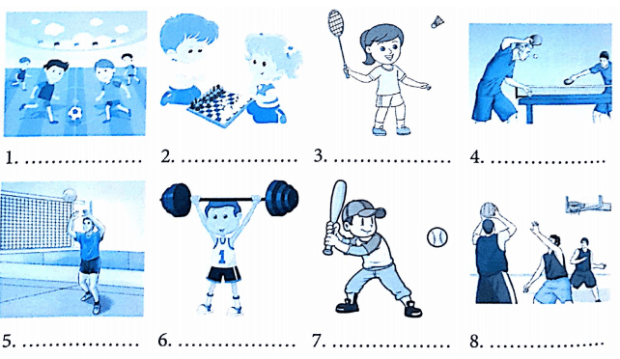
Exercise 2: Complete the sentence with a suitable word.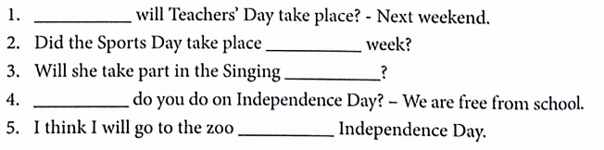Exercise 3 : Read and match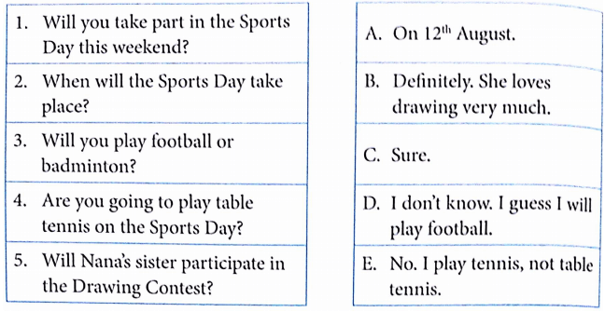
Exercise 4: Circle the correct answer.
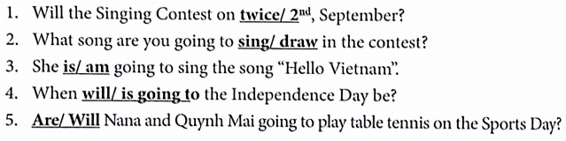Exercise 5: Read and complete.
Our school Sports Day will be next Saturday. Everyone in my class is ready for it. Trung and Dung are going to play (1)…………tennis. Minh and Dieu Nhi are going to (2) ……….badminton. Thu is (3)………to play basketball. Hoang is going to (4)…… My classmates are (5)………… hard for the event. We hope that we will do well.
Exercise 6: Write about you.
- When will your School Sports Day be?...................................................................
- Where will it be?......................................................................................................
- What are you going to do on that day?....................................................................
- What are your classmates going to do on that day?.................................................

Đáp án
Exercise 1:
1 - play football
2 - play chess
3 - play badminton
4 - play table tennis
5 - play volleyball
6 - weight lifting
7 - play baseball
8 - play basketball

Exercise 2:
- When 2. On 3. Contest 4. What. 5. on
Exercise 3:
1 | c
2 | a
3 | d
4 | e
5 | b

Exercise 4:
- 2nd 2. Sing 3. Is 4. Will 5. Are
Exercise 5: Read and complete.
Our school Sports Day will be next Saturday. Everyone in my class is ready for it. Trung and Dung are going to play (1) table tennis. Minh and Dieu Nhi are going to (2) play badminton. Thu is (3) going to play basketball. Hoang is going to (4) swimming/ fishing. My classmates are (5)practising hard for the event. We hope that we will do well.
Exercise 6: Write about you.
Answer vary

