PHIẾU BÀI TẬP MÔN TIẾNG ANH LỚP 5 (phiếu 14)
- Look at the pictures, ask and answer then write four sentences.
Model sentence: Where will you be this weekend?
I think I’ll be _______.
a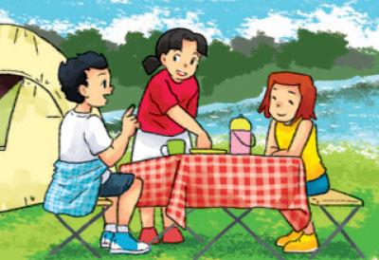 b. 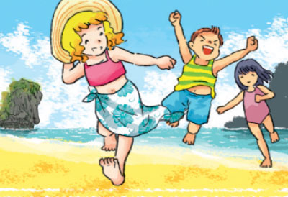
c. 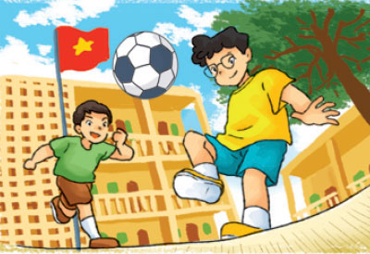 d. 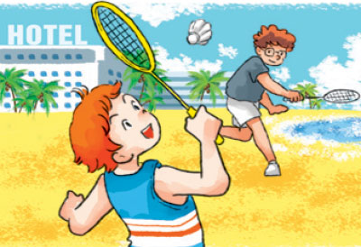
a. ……………………………………………………………………………….
b. ……………………………………………………………………………….
c. …………………………………………………………………………………
d. ………………………………………………………………………………..
- Read and circle a or b
Linda usually goes to school in the morning. Yesterday, she didn’t go to school because it was Sunday. She went shopping with her mother after breakfast. They shopped for food and drink and a lot of things for the family. In the afternoon, the family visited Linda’s grandparents in the countryside. The grandparents were very happy to see them. The family enjoyed their day in the countryside and went back home in the evening. Next week, they will visit Linda’s grandparents again.
1.What does Linda usually do in the morning?
a.She does morning exercise.
b.She goes to school.
- Did she go to school yesterday?
a.Yes, she did.
b.No, she didn’t.
- Where did she go in the morning?
a.She went shopping.
b.She went to the countryside.
- Where do Linda’s grandparents live?
a.In the city.
b.In the countryside.
- When will the family visit Linda’s grandparents?
a.Next week.
b.Next month.
III. Read and answer
1.Where will you be this weekend?
…………………………………………………………………………………………
2.Where will Mai be tomorrow?
………………………………………………………………………………………….
3.Where will Phong be next week?
………………………………………………………………………………………….
4.Where will Peter and Linda be next month?
………………………………………………………………………………………….
IV.Write about you
Hi. My name’s …………………………………………………………….
Next Summer holiday , I think I will be …………………………………..
In the morning, I will ………………………………………………………
In the afternoon, …………………………………………………………..
In the evening, …………………………………………….....

ĐÁP ÁN
I. Look at the pictures, ask and answer then write four sentences.
- Where will you be this weekend? I think I’ll be in the countryside
- Where will you be this weekend? I think I’ll be on the beach.
- Where will you be this weekend? I think I’ll be at school.
- Where will you be this weekend? I think I’ll be by the sea.
II.Read and circle a or b
Linda usually goes to school in the morning. Yesterday, she didn’t go to school because it was Sunday. She went shopping with her mother after breakfast. They shopped for food and drink and a lot of things for the family. In the afternoon, the family visited Linda’s grandparents in the countryside. The grandparents were very happy to see them. The family enjoyed their day in the countryside and went back home in the evening. Next week, they will visit Linda’s grandparents again.
1.What does Linda usually do in the morning?
b.She goes to school.
- Did she go to school yesterday?
b.No, she didn’t.
- Where did she go in the morning?
a.She went shopping.
- Where do Linda’s grandparents live?
b.In the countryside.
- When will the family visit Linda’s grandparents?
a.Next week.
III. Read and answer ( Answer vary)
1.Where will you be this weekend? I’ll be at home.
2.Where will Mai be tomorrow? She’ll be on the beach.
3.Where will Phong be next week? He’ll be in the countryside.
4.Where will Peter and Linda be next month? They’ll be at school
IV.Write about you( Answer vary)

