PHIẾU BÀI TẬP MÔN TIẾNG ANH LỚP 5 (phiếu 17)
- Look and make sentences.
Model sentence: What’s An Tiem like?He’s hard –working.

A. B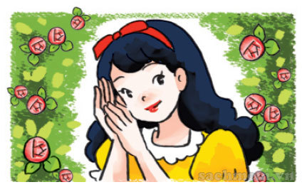
c. 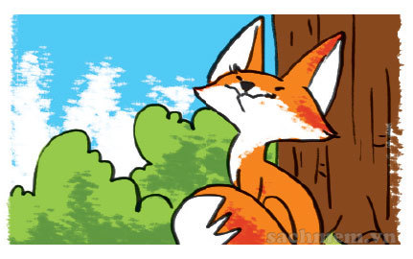 D. 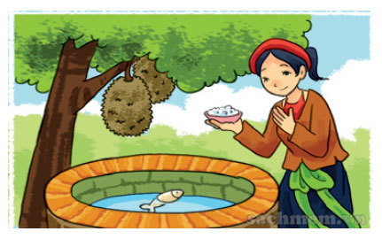
- ………………………………………………………………………..
- ……………………………………………………………………….
- ………………………………………………………………………..
- ……………………………………………………………………......
- Read and circle a or b
1.What are you reading?
a. I’m reading The Fox and the Crow.
b. She is reading Aladdin and the Magic Lamp.
2.What’s she reading?
a. She’s reading a fairy tales.
b. She reads a funny story.
3.What’s An Tiem like?
a.He is a hard-working.
b.He is clever
4.What’s Aladdin like?
a. He is generous.
b.He is a clever.
Read and tick Yes( Y) or No (N).
Tom likes reading. On Sundays, he often stays at home and reads comic books. He likes Case Closed very much. It is a Japanese story. The main character is a schoolboy called Jimmy Kudo. He often helps the police. He is good at his job. Jimmy Kudo is Tom's favourite character because he is clever and brave.
 | Y | N
1.Tom likes reading books in his free time.
2.Case Closed is a Malaysian story.
3.The main character is Jimmy Kudo.
4.Jimmy Kudo is a policeman.
5.Jimmy Kudo is clever and brave.
- Look and repeat
- 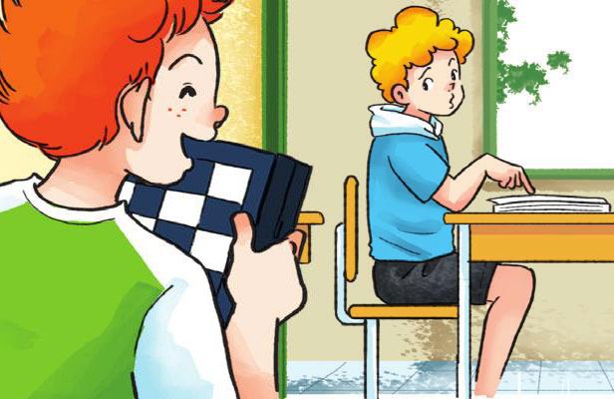
Tony: Hi, Peter. Let’s play chess.
Peter: I can’t. I’m reading.
B. 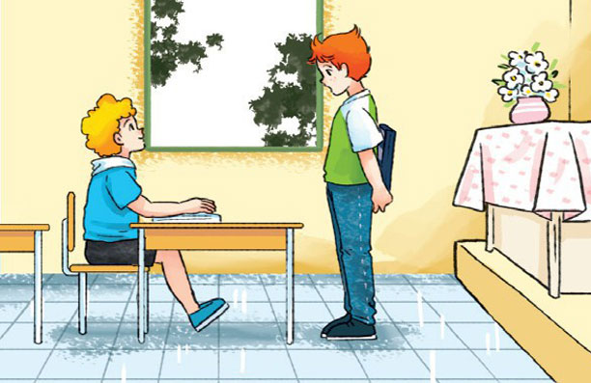
Tony: What are you reading?
Peter: I’m reading a story about Halloween
C.
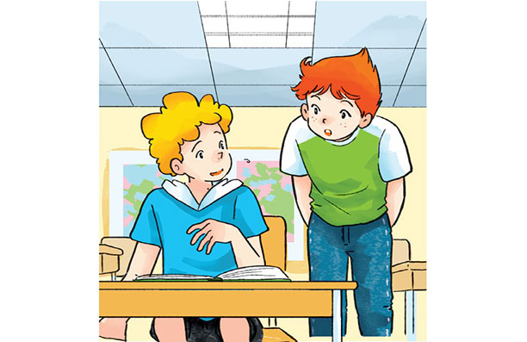

Tony: Is it a ghost story?
Peter: Yes. Very scary.
D.
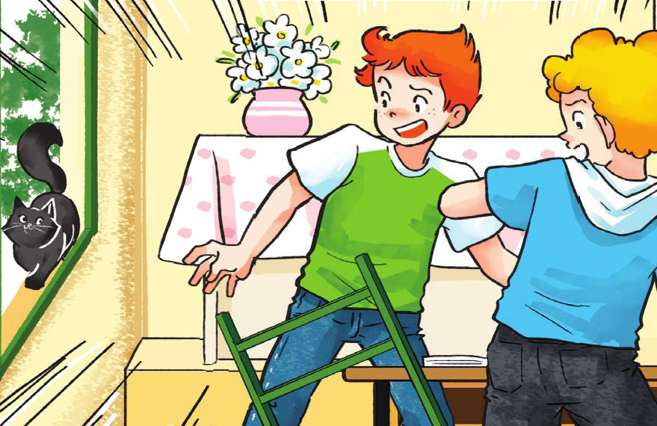
Tony: Is it a ghost?
Peter:

Đáp án
- Look and make sentences.
a/ What’s An Tiem like? He’s hard –working.
b/ What’s Snow White like? She’s kind.
c/ What’s The Fox like? He’s clever
d/ What’s Tam like? Shee’s gentle.
- Read and circle a or b
1.What are you reading?
a. I’m reading The Fox and the Crow.
2.What’s she reading?
a. She’s reading a fairy tales.
3.What’s An Tiem like?
b.He is clever
4.What’s Aladdin like?
a. He is generous.
Read and tick Yes( Y) or No (N).
Tom likes reading. On Sundays, he often stays at home and reads comic books. He likes Case Closed very much. It is a Japanese story. The main character is a schoolboy called Jimmy Kudo. He often helps the police. He is good at his job. Jimmy Kudo is Tom's favourite character because he is clever and brave.
 | Y | N
1.Tom likes reading books in his free time. | Y
2.Case Closed is a Malaysian story. |  | N
3.The main character is Jimmy Kudo. | Y
4.Jimmy Kudo is a policeman. |  | N
5.Jimmy Kudo is clever and brave. | Y

